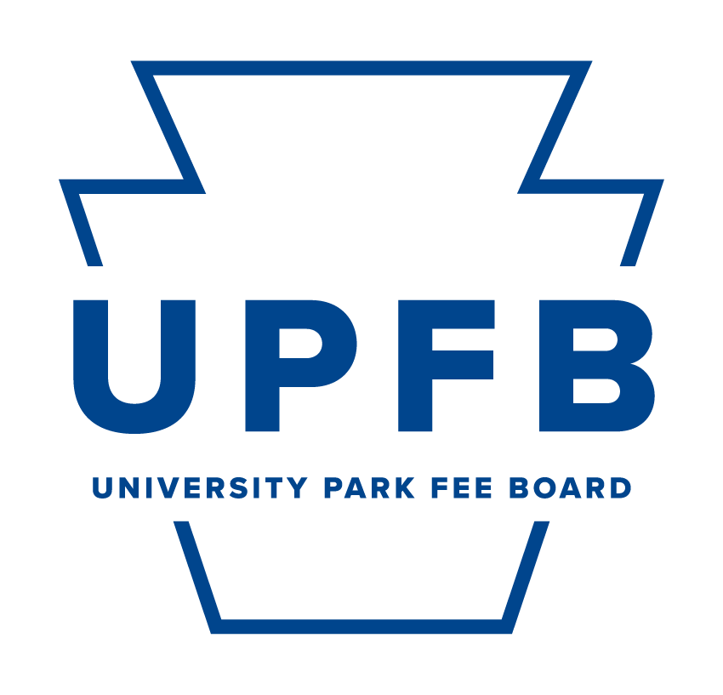
UPFB FY 25-26 New Infrastructure and Facilities Project Proposal

[Name of unit]
[Project name]
[Name, position, title of submitter, and PSU Email]

Delete the following points below after reading:

- This is the template for proposals for one-time projects related to physical improvements to facilities and campus infrastructure that support the student's out-of-class experience. Example projects include student center renovations and feasibility studies for projects like the Zero Emissions Fleet effort and the installation of free menstrual-product dispensers across the University Park campus.

- There is a 15-page limit on the proposal.

- The inclusion of addenda or supplemental materials will not count towards this limit.

Project Overview
Provide a narrative of your unit’s presence within the Penn State student body at University Park. To supplement the University Park Fee Board’s (UPFB) understanding of your unit’s engagement, summarize your unit’s operations and their direct correlation to the co-curricular benefit of students. Utilize the following subheadings to guide your response and include additional context if necessary:

Project Name:

Cost (if this cost is an estimation, please include a range)
[Answer here.]

Has this project conducted a feasibility study (Y/N)
[Answer here.]

If “No,” does this feasibility study require funding from the University Park Fee Board?
[Answer here.]

Proposed Dates of Implementation (Start to Completion)
[Answer here.]

Project Type (Category)
[Answer here.]

Demonstration
[Provide a summarized description of the proposed project (300-word limit)]

[Provide a detailed description of the project’s potential impact on the student body. This should include, but not be limited to, the following criteria]:
- Impact on the co-curricular, out-of-class student experience.
- Impact of the unit(s), person(s), and entity(s) involved in utilizing the end results of the project.

Criteria
Please answer the following questions with a Yes (Y), No (N), or Unsure and a short narrative supporting your response.

- Is there ongoing or past collaboration with students on this project's formulation?
- Does this project have approval of the relevant campus department/office(s)? Does the applicant or their respective office(s) have the capacity to complete this project?
- Does this project have a timeline and budget that can be presented to the Fee Board, in full, in Spring 2024?
- Have you contacted OPP to identify the appropriate resources and timelines established for this project if approved by the UPFB?
- Are the relevant staff prepared to seek signed approval for local, state, or federal permitting if applicable?
- Does this project include a plan for long-term maintenance and operations that can be operationalized without additional funding from the Fee Board?
- Are there any efforts to cost-share this project through philanthropy or partnership?
- Will the project be completed within 5 years of receiving initial funding?
- If this project receives funding from the Fee Board, you will be expected to submit an annual fee usage report and a final report (within 6 years of receiving initial funding) outlining how the project went and whether it achieved the expected outcomes. Will you complete these reports?
- Does this project satisfy all other Fee Board requirements (See Handbook Section 7.1: “Limitations of Fee Use’ and Section 7.2: “Items That Will Not Be Funded”?).

Supplemental Criteria
[Have alternative funding sources for this project been examined? Will there be a financial contribution to this project from another University entity? Please list other funding sources if applicable. If the answer is no to any of these questions, please explain.]

Contact
[Provide an established source of contact, including email address, phone number, and office/department for further clarification and contact.]

Other
[Provide any other information about this project that would aid the Fee Board in understanding the feasibility of the proposed project (data, graphs, images, etc.).]

