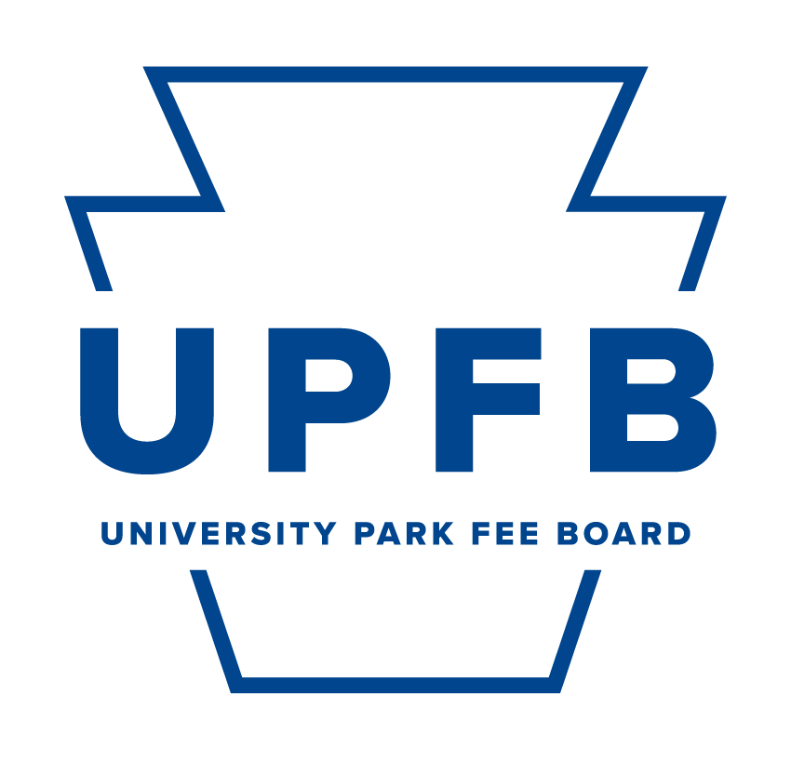
Meeting Agenda
February 23, 2024 | 9:00-10:30am | Hub Room 102

- Call to Order and Opening Roll Call
- Adoption of Meeting Minutes (2/16)
- Adoption of the Agenda
- Public Comment
- Old Business
  - Paul Robeson Cultural Center FY2025 Budget Modification Proposal
  - Student Leadership and Involvement FY2025 Budget Modification Proposal
  - Penn State Sustainability FY2025 Budget Modification Proposal
  - Keiko Ross Student Farm FY2025 Budget Modification Proposal
  - Student Orientation and Transition Programs FY2025 Budget Modification Proposal
  - Campus Recreation FY2025 Budget Modification Proposal
  - OriginLabs FY2025 New Funding Appropriation Proposal
- New Business
  - FY2026 Materials and Process Presentation
- Chair Report (Najee Rodriguez)
- Vice-Chair Report (Cierra Chandler)
- Executive Committee Reports
  - Office of Strategic Communications (Camryn O’Rourke, Maggie Atkins)
  - Chief Budget and Planning Executive (Danil Kurtz)
  - Chief Administrative Executive (Rayna Alexander)
- Comments for Good of the Order
- Closing Roll Call

