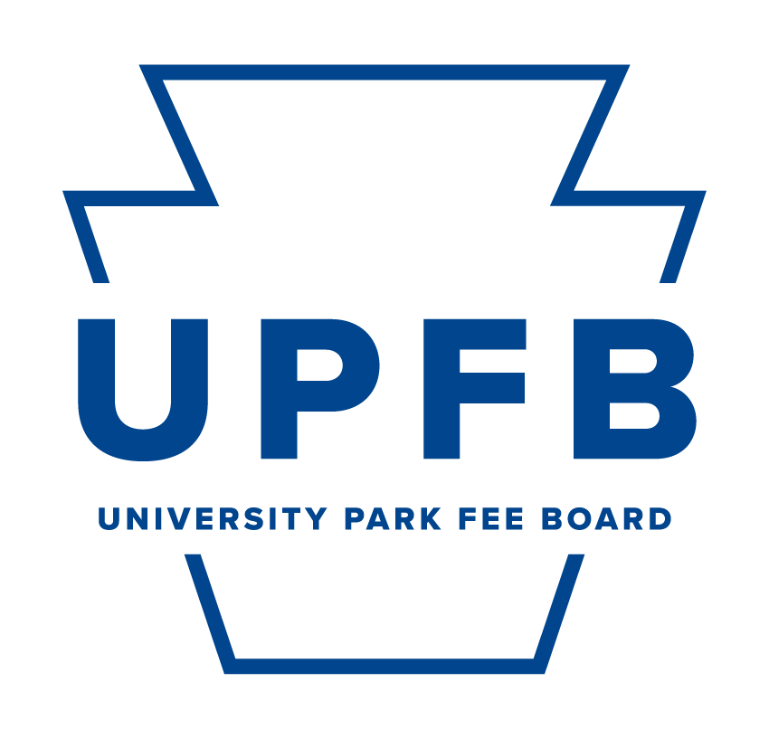
Meeting Agenda
January 12, 2024 | 9:00-10:30am | Hub Room 102

- Call to Order and Opening Roll Call
- Adoption of the Agenda
- Public Comment
- New Business
  - Overview of Spring semester expectations
  - University Park Fee Board Headshots and group photos
- Topics of Discussion
  - Strategic Planning Committee Update
  - Holistic Task Force Recommendation review
- UPAC Chair Report
- Chair Report
  - Documented in email
- Comments for Good of the Order
- Closing Roll Call

