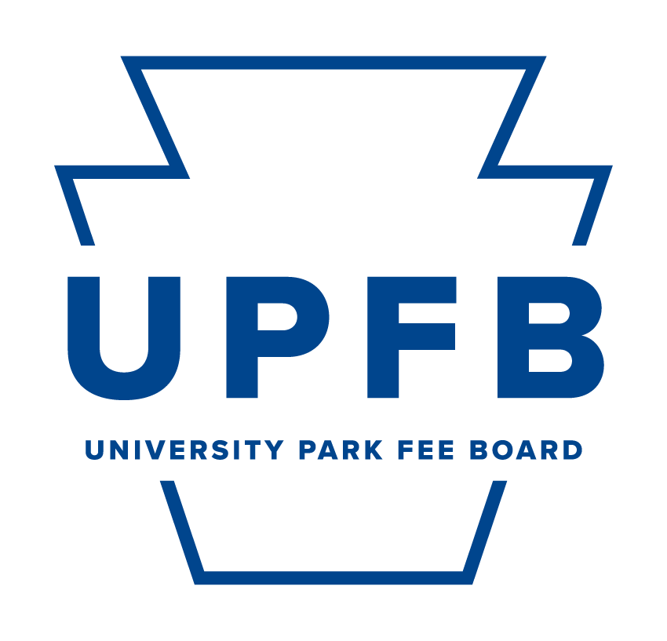
UPFB FY 25-26 Standing Funding Appropriation Proposal

[Name of unit]
[Name, position, title of submitter, and PSU Email]

Delete the following points below after reading:

- Units funded annually after approved funding from the UPFB are standing funding appropriations.

- There is a 15-page limit on the proposal.

- The inclusion of addenda or supplemental materials will not count towards this limit.

- In addition, we encourage you to review the example of a completed funding proposal posted on the website for further guidance.

Introduction
Provide a narrative of how the SIF funding has been pivotal in advancing your unit's mission and enhancing student experiences at Penn State University Park. Emphasize the tangible outcomes and improvements made possible by this funding. Utilize the following subheadings to guide your response and include additional context if necessary:

Unit Basic Information
[Provide a general explanation of your unit, its purpose, and information related to your unit’s engagement, size, and connection to the student body and co-curricular experience. Remember, new UPFB Representatives will be reviewing.]

Unit Ongoing Impact and Development
[Briefly highlight how your unit has evolved and sustained its impact on the University Park student community since the last funding cycle.]

Recent Developments and Achievements
[Outline key developments, achievements, and any changes in your unit’s operations since the last funding cycle related to initiatives or services funded by the SIF.]

Proposed FY 25-26 Budget Narrative
In this section, provide a comprehensive narrative of your FY 25-26 budget and explanation for any variations in your budget proposal compared to FY 24-25. This should include detailing the reasons behind increases or decreases in the funding amount and how these changes align with your unit’s objectives and evolving needs.
Proposed FY 25-26 Budget Strategy and Goals
[Provide a general narrative for your unit’s proposed FY 25-26 budget, focusing on how your proposal builds on past achievements and evolving needs. Ensure that the reasons are well-explained and justified in the context of your unit’s mission, student needs, and the broader objectives of the University Park Fee Board.]

Reason for Budget Increase/Decrease
[Explain the specific factors and strategy contributing to the change in your budget proposal from the previous FY. This could include expansion of services, cost adjustments due to inflation, new initiatives, discontinuation of certain programs, or changes in operational costs. Write N/A if not applicable to your proposal (e.g., flat-funding).]

Impact on Operations and Services
[Describe how the change in the budget request will impact your unit's operations and services. For an increased budget, explain how the additional funds will enhance or expand services. For a decreased budget, detail how you will maintain or adapt services with reduced funding. Write N/A if not applicable to your proposal (e.g., flat-funding).]

Budget Amount and Timeline
Outline your unit’s total budget for FY 25-26, specifying the services and programs that you hope to be funded by the Student Initiated Fee. Include separate budget sections for the fall semester, spring semester, and summer. These budgets should include the breakdown of the appropriation and how it will be distributed. If possible, the anticipated timeline of use of funds also needs to be included. It is understood by the UPFB that there cannot be a timeline provided for all requests, however, any information that can be provided will be of assisstance. The budget should also show the breakdown and utilization of dollars using total dollar amounts; do not try to break this number down into a “per student” figure that would detail what each student would contribute to the funding. It is recommended that you refer to the New Fee Funding Proposal example located on the website.

You may also refer to the table below for a better understanding:
Do | Don’t
Example Distribution of Request:  Online Student Resources: $50,000  Student Staff Wages: $20,000  Salaries and Fringe Benefits: $200,000 (3 full-time positions)  Facilities Upgrades: $30,000  Programming Event 1: $10,000  Speaker 1: $5,000  Promotional and Marketing Materials: $5,000  Total Request: $320,000 | Example Distribution of Request:  Online Student Resources: $1.00  Student Staff Wages: $0.30  Salaries and Fringe Benefits: $2.00 (3 full-time positions)  Programming Event 1: $0.20  Programming Event 2: $0.60  Speaker 1: $0.10  Promotion Materials: $0.10  Total Request: $4.30 per student

Quantifiable Impact and Effectiveness
The UPFB’s sustained appropriation of annual funding is based on each unit’s continued impact on the student body through their services and programs. An important factor in our assessment is the effectiveness of ongoing collaborations and the sustainable use of funds. We encourage units to provide updated data that reflects the utilization and impact of services since the last funding cycle, highlighting any changes or consistent trends. If certain metrics are not applicable, please provide a brief explanation.

Continued Collaboration and Cost-Sharing
[Describe ongoing or planned efforts to sustain cost-sharing and resource optimization. Highlight any continuing collaborations with student organizations like the Student Programming Association, community sources, or other units. Other examples that can described are unit efforts to receive grants or external funding. This should also include any philanthropic efforts that your unit may have pursued. Focus on the continued pursuit of joint initiatives and the efficiency of resource use.]

Updated Marketing and Outreach Efforts
[Provide details on your unit's ongoing outreach efforts. Include information on how marketing strategies have evolved or been maintained to ensure student engagement, using examples such as social media campaigns, surveys, or digital interactions.]

Ongoing Surveys, Data, and Metrics
[Present updated survey data, utilization rates, and other metrics that demonstrate the continued need and effectiveness of your unit’s services. Include any tools or methods used to track and evaluate the ongoing engagement and impact of your services and programs.]

Updated Testimonials
[If applicable, provide recent testimonials from students, staff, or other leadership that underscore the ongoing relevance and importance of your unit’s operations.]

UPFB Budget Model Applicability
As a unit that continues to benefit from the UPFB's funding, there is an ongoing expectation that proposals, when applicable, align with the Student Needs-Based Budget Model designed by the UPFB. This model focuses on data-driven budgeting, collaboration, and transparency. Explain below how your proposal remains student-centric, ensuring that your funding decisions consistently align with the Student Fee Board’s values and the evolving needs of students.
Alignment with Budget Model Strategic Priorities
The budget model prioritizes funding strategic investments in four critical areas: fulfilling critical staffing needs and raising student staff compensation, upgrading campus facilities and infrastructure, and transforming programming funds for more impactful campus activities. These priorities are designed to respond to the student community's immediate needs and to prepare for future challenges, ensuring the university environment is supportive and conducive to student success by funding critical priorities.

In order, and when applicable, please briefly describe how your funding proposal aligns with the components of the UPFB’s strategic priorities listed below. Write N/A for the strategic priorities not applicable to your proposal.

- Addressing Critical Staffing Needs
[Please briefly describe your staffing need(s) and how your funding proposal addresses deficits in staff to provde quality support to students. Write N/A if not applicable to your proposal.]

- Increasing Student Wages
[Please briefly describe how your funding proposal supports reasonable increases to student wages. Write N/A if not applicable to your proposal.]

- Enhancing Student Spaces through Facilities and Infrastructure Development
[Please briefly describe how your funding proposal supports facilities and infrastructure development for student spaces. Write N/A if not applicable to your proposal.]

- Transforming Programming Funds for Impactful, Collaborative Campus Activites
[Please briefly describe how your funding proposal aims to responsibly and collaboratively utilize programming funds. In addition, specifically highlight information related to the current/anticipated involvement of students and current cost-sharing collaborative efforts/anticipated efforts for programming. Write N/A if not applicable to your proposal.]

Alignment with Budget Model Goals
The goals of this budget model focus on securing basic needs for all students; ensuring a sustainable future; strengthening campus infrastructure and facilities; promoting diversity, equity, inclusion and belonging; enhancing recreation and entertainment opportunities; and encouraging student programming and involvement. Each goal is carefully designed to contribute to a supportive, enriching, and inclusive university environment, catering to the student body's immediate and long-term needs. Your proposal should align with at least one of the goals listed below.

- Securing Basic Needs for All Students
[Please briefly describe how your funding proposal aims to foster a supportive and caring environment with robust support systems ensuring that every student has a stable foundation upon which they can build their academic and personal lives (e.g., proposals related to food, housing, health, and other basic needs). Write N/A if not applicable to your proposal.]

- Ensuring a Sustainable Future at Penn State
[Please briefly describe how your funding proposal aims to incorporate facets environmental sustainability (e.g., initiatives or efforts to reduce the campus's carbon footprint to integrating sustainability into daily operations and through student-driven initiatives). Write N/A if not applicable to your proposal.]

- Strengthening Infrastructure and Facilities
[Please briefly describe how your funding proposal aims to invest in student-facing physical spaces (e.g., new buildings, room renovations, and facility upgrades. Write N/A if not applicable to your proposal.]

- Enhancing Recreation and Entertainment
[Please briefly describe how your funding proposal enhances recreation and entertainment for students to ensures that they have access to spaces and programs that contribute to their physical, mental, and emotional well-being (e.g., sports facilities, performing arts and cultural centers, and concerts.) Write N/A if not applicable to your proposal.]

- Promoting Diversity, Equity, Inclusion, and Belonging
[Please briefly describe how your funding proposal promotes an inclusive and equitable student community by supporting cultural understanding, equity in opportunities, and a sense of belonging for students from historically underrepresented communities and students who hold different perspectives. Write N/A if not applicable to your proposal.]

- Encouraging Collaborative Student Programming and Involvement
[Please briefly describe how your funding proposal aims to foster active student participation in your proposed programs and initiatives (e.g., student-led clubs, organizations, events, leadership and professional development, etc.). Write N/A if not applicable to your proposal.]

Future Considerations
- Highlight any anticipated changes or considerations that may affect future funding proposals.
Conclusion
- Summarize the continued benefits of your unit’s services and programs, and the importance of the Student Initiated Fee as a funding mechanism.

Appendices (If Necessary)
- Attach any additional data or information that could assist the Fee Board in evaluating your ongoing funding request.

