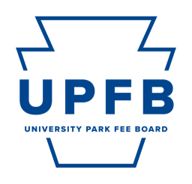
University Park Fee Board Public Meeting Agenda
April 18, 2024 | 7:00-9:00pm | Hub Room 229

- Call to Order, Opening Roll Call, Chair Remarks

- Consent Action Items
- Approval of Minutes from the April 12th Meeting

- Adoption of the Agenda

- Public Comment

- Reports from Standing Committees
Discussion of action and/or information items by the Standing Committees for consideration by the University Park Fee Board:
- Committee on Facilities and Capital Planning
- Committee on Strategic Planning and Internal Operations
- Committee on Outreach and Student Relations
- Committee on New Funding Proposals

- Other Action Items
    - FY 26 Student Leadership and Involvement Standing Funding Appropriation Proposal (SPA, Homecoming)
    - FY 26 University Health Services Standing Funding Appropriation Proposal
    - FY 26 Penn State Sustainability Standing Funding Appropriation Proposal
    - FY 26 Bank of America Career Services: Professional Attire Closet Standing Funding Appropriation Proposal
    - FY 26 Millenium Scholars New Funding Proposal
    - FY 26 Anthology Engage Platform New Funding Proposal
    - Pilot Program Policy Authorization Vote

- Chair Report and Discussion (Najee Rodriguez)
    - End-of-Year Reception
    - Student Staff Wage Classification Update

- Executive Committee Reports
    - Vice-Chair (Cierra Chandler)
    - Office of Strategic Communications (Camryn O’Rourke, Maggie Atkins)
    - Chief Budget and Planning Executive (Danil Kurtz)
    - Chief Administrative Executive (Rayna Alexander)

- Comments for Good of the Order

- Closing Roll Call

