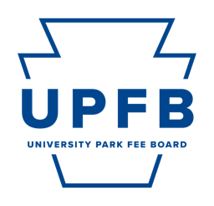
University Park Fee Board Public Meeting Agenda
April 26, 2024 | 9:00am | Hub 102

- Call to Order, Opening Roll Call, Chair Remarks

- Consent Action Items
- Approval of Minutes from the April 18th Meeting
- Approval of Minutes from April 19th Meeting

- Adoption of the Agenda

- Public Comment

- Reports from Standing Committees
Discussion of action and/or information items by the Standing Committees for consideration by the University Park Fee Board:
- Committee on Facilities and Capital Planning
- Committee on Strategic Planning and Internal Operations
- Committee on Outreach and Student Relations
- Committee on New Funding Proposals

- Other Action Items
    - FY 26 OriginLabs Standing Funding Appropriation Proposal
    - FY 26 News Consortium Standing Funding Appropriation Proposal
    - FY 26 Paul Robeson Cultural Center Standing Funding Appropriation Proposal
    - FY 26 Standing Funding Appropriations Deliberations
    - FY 26 New Funding Appropriation Proposal Deliberations
    - FY 26 Infrastructure and Facilities Proposal Deliberations

- Chair Report and Discussion (Najee Rodriguez)
    - End-of-Year Reception Planning

- Executive Committee Reports
    - Vice-Chair (Cierra Chandler)
    - Office of Strategic Communications (Camryn O’Rourke, Maggie Atkins)
    - Chief Budget and Planning Executive (Danil Kurtz)
    - Chief Administrative Executive (Rayna Alexander)

- Comments for Good of the Order

- Closing Roll Call

