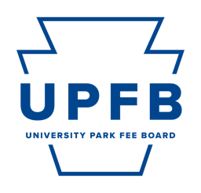
University Park Fee Board Public Meeting Agenda
April 5, 2024 | 9:00-10:30am | Hub Room 102

- Call to Order, Opening Roll Call, Chair Remarks

- Consent Action Items
- Approval of Minutes from the March 29th 2024 Meeting

- Adoption of the Agenda

- Public Comment

- Reports from Standing Committees
Discussion of action and/or information items by the Standing Committees for consideration by the University Park Fee Board:
- Committee on Facilities and Capital Planning
- Committee on Strategic Planning and Internal Operations
- Committee on Outreach and Student Relations
- Committee on New Funding Proposals

- Other Action Items
    - Continued Discussion of Lion’s Pantry FY 2026 Standing Funding Appropriation Proposal
    - Discussion of Student Legal Services FY 2026 Standing Funding Appropriation Proposal
    - Discussion of the Office of Graduate Educational Equity Programs FY 2026 Standing Funding Appropriation Proposal
    - Discussion of the Center for Performing Arts FY 2026 Standing Funding Appropriation Proposal
    - Discussion of Counseling and Psychological Services FY 2026 Standing Funding Appropriation Proposal
    - Discussion of HUB-Robeson Center Reserve FY 2026 Standing Funding Appropriation Proposal

- Chair Report and Discussion (Najee Rodriguez)
    - 2025 Student Fee Board Strategic Planning Committee Approval
    - Recruitment of UPFB Student Staff
    - Scheduling of Off-Cycle Meetings

- Executive Committee Reports
    - Vice-Chair (Cierra Chandler)
    - Office of Strategic Communications (Camryn O’Rourke, Maggie Atkins)
    - Chief Budget and Planning Executive (Danil Kurtz)
    - Chief Administrative Executive (Rayna Alexander)

- Comments for Good of the Order

- Closing Roll Call

